**To Create RDS Database**

**Step-1**

**Search service and click 🡪RDS**

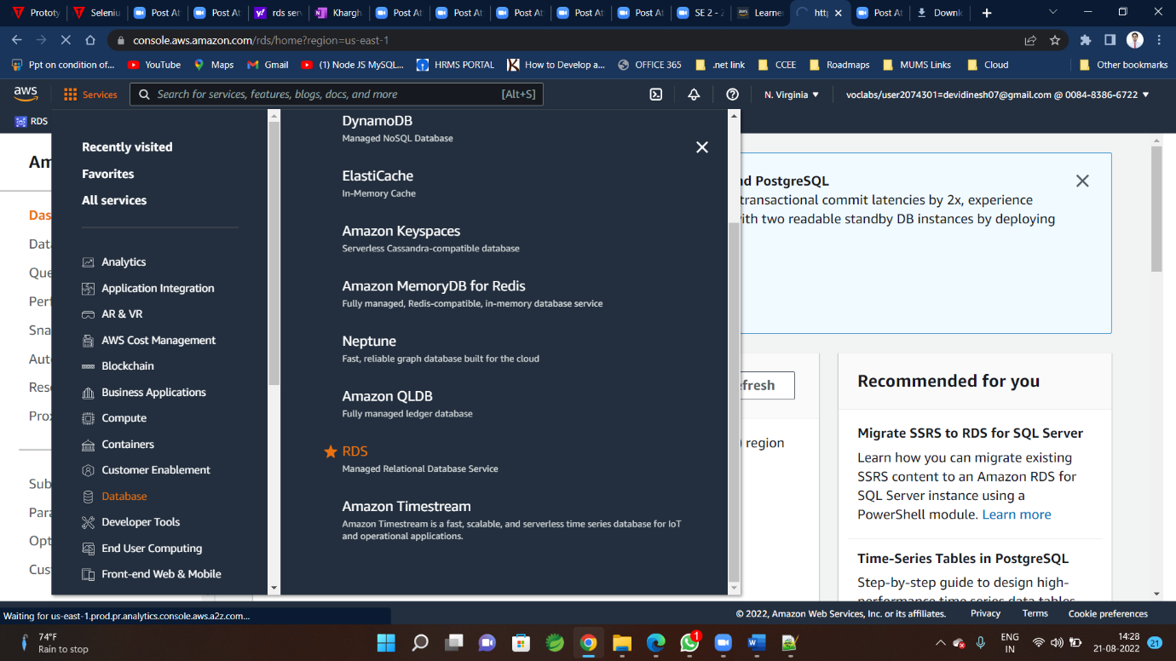

**Step-2**

**Click on Create Database**

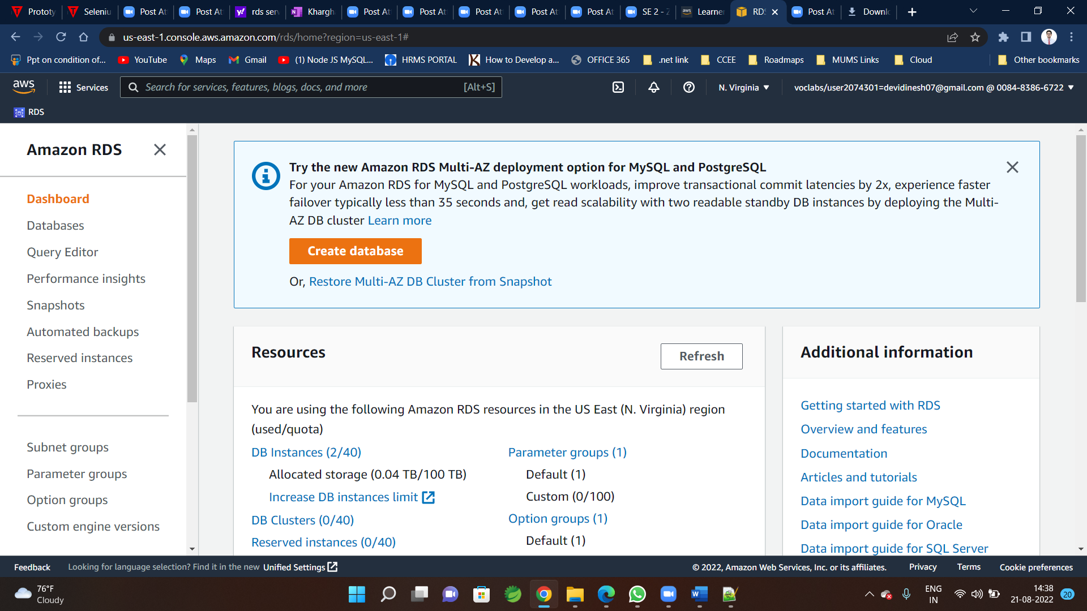

**Step-3**

**Keep standard create**

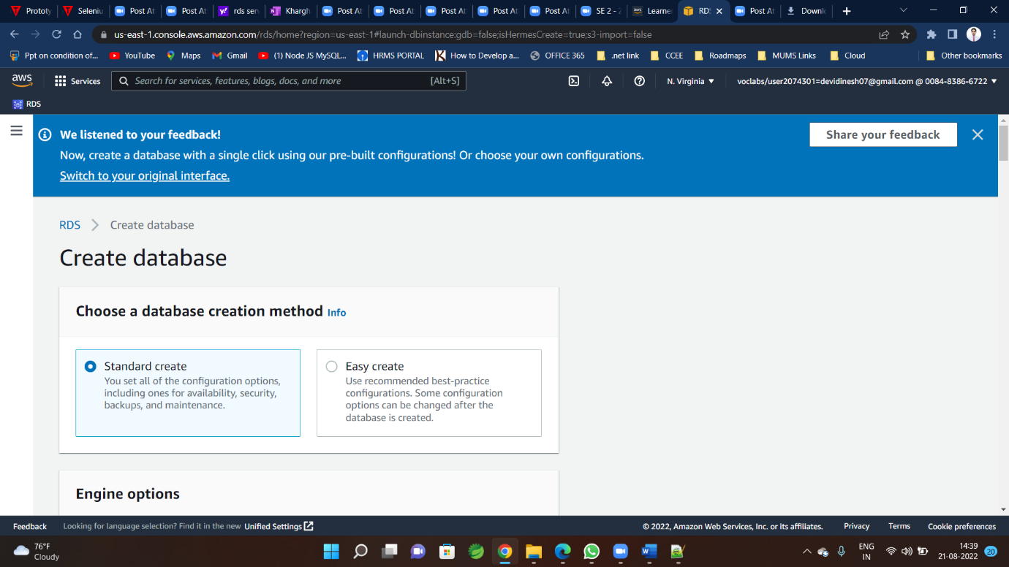

**Step-4**

**Select Database**

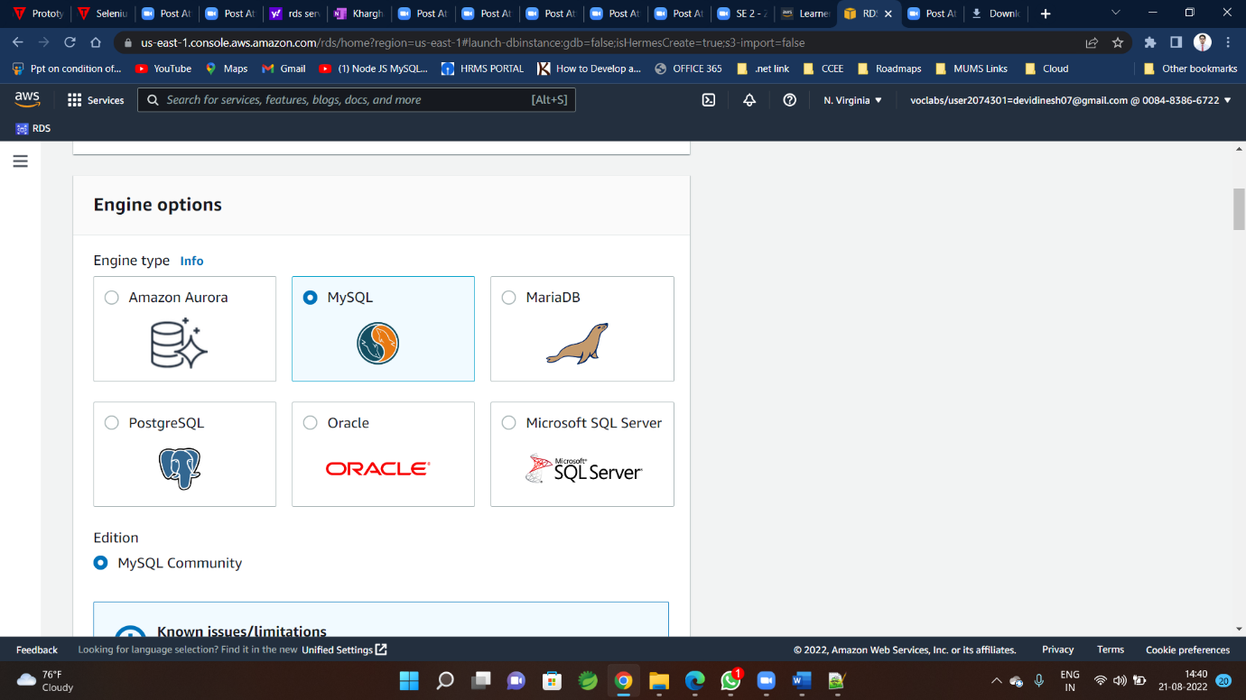

**Step-5**

**Select version as per your installed Mysql version**

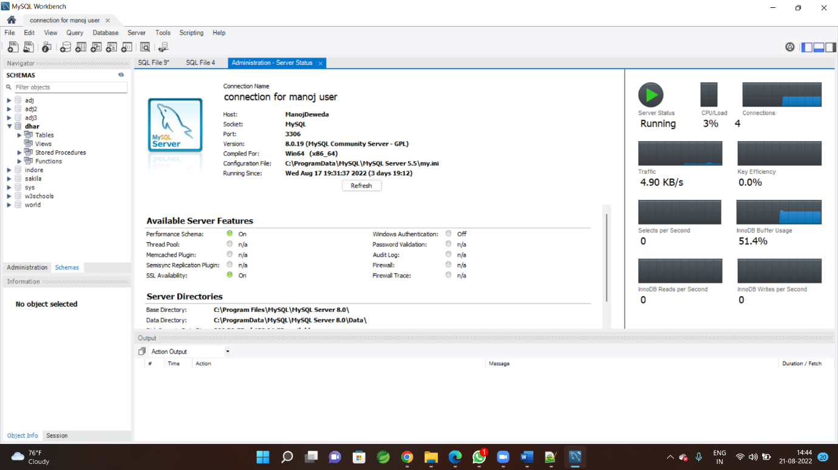

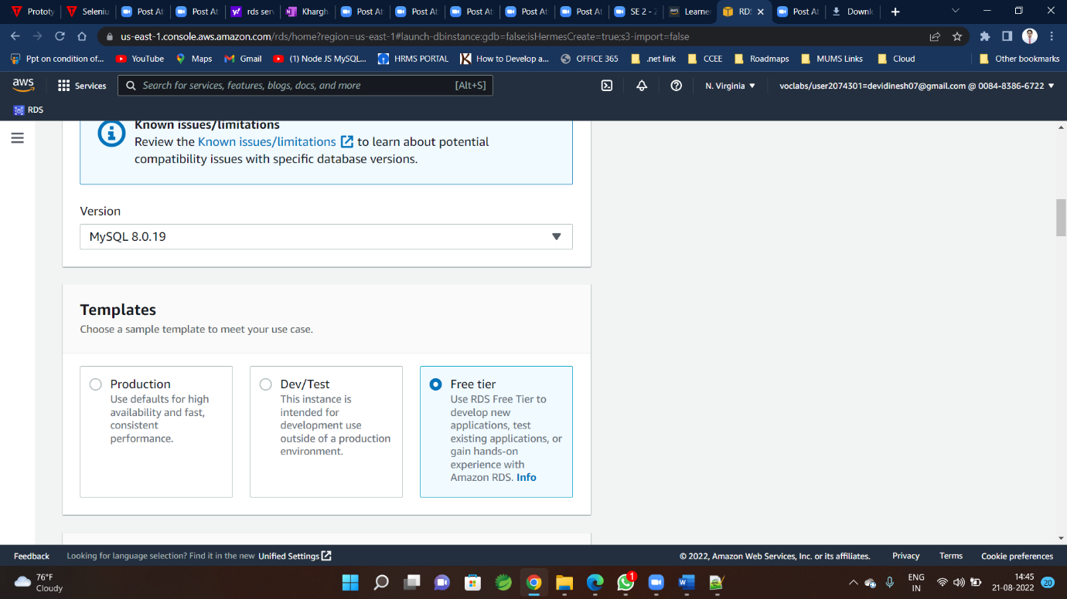

**Carefully Select template as free Tier otherwise charges may be higher**

**Step-6**

**Create database Name ,username and password(most important keep it with you) after genration**

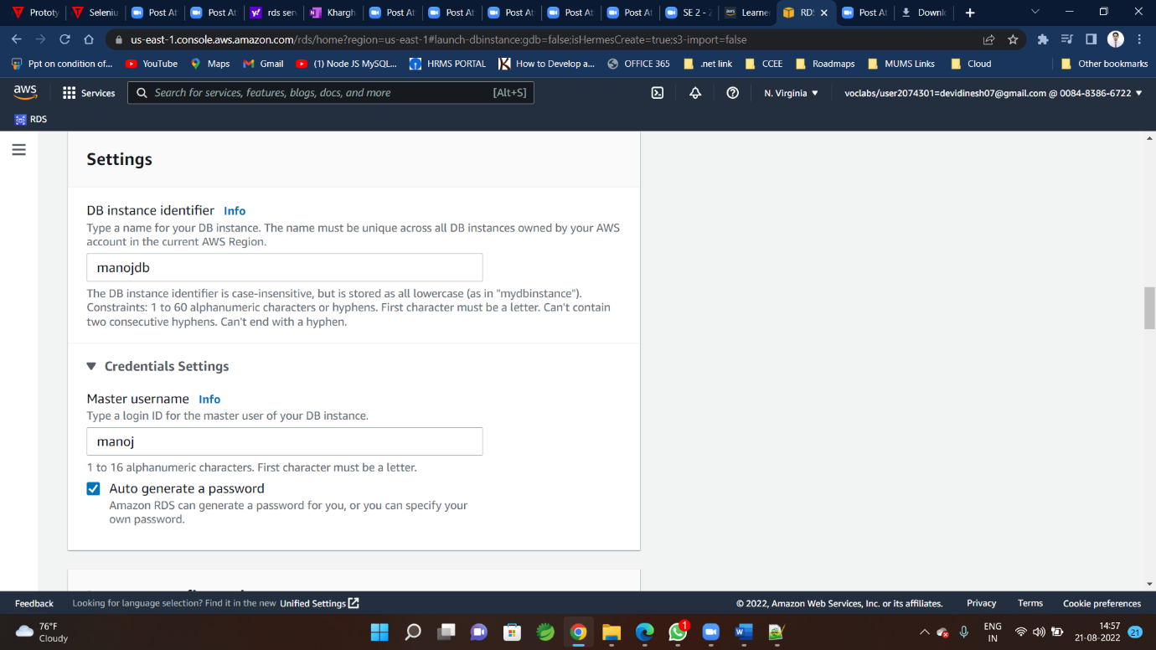

**Step-7**

**Computing power of Database server**

**Select as per you requirement**

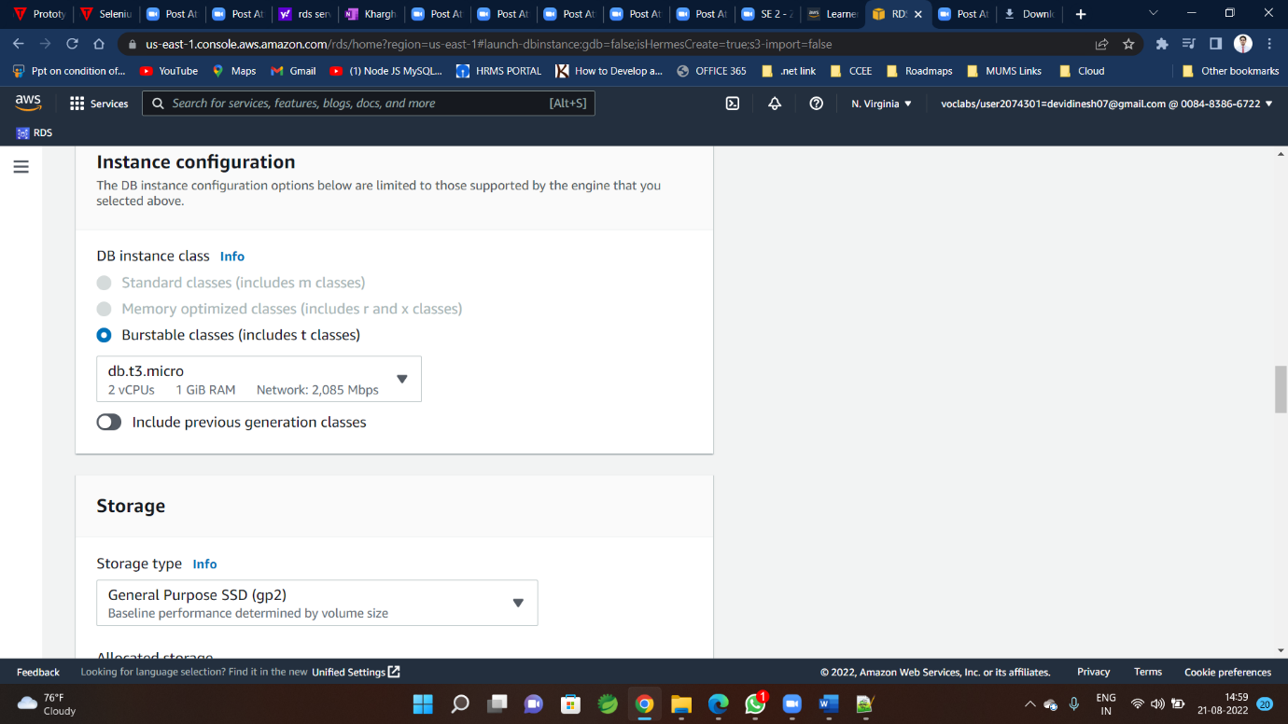

**Step-8**

**Storage (ssd ) of Database server select as per requirement**

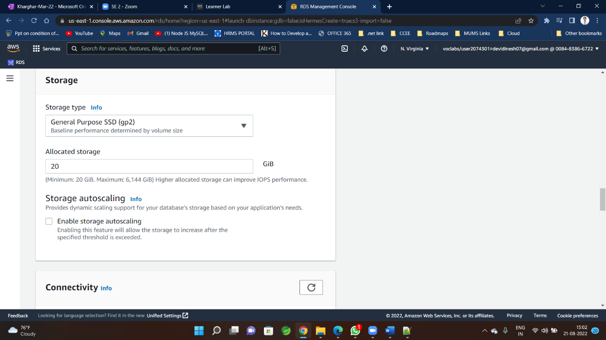

**Keep Auto scaling off**

**Step-9**

**Connectivity🡪 click yes to access outside EC2**

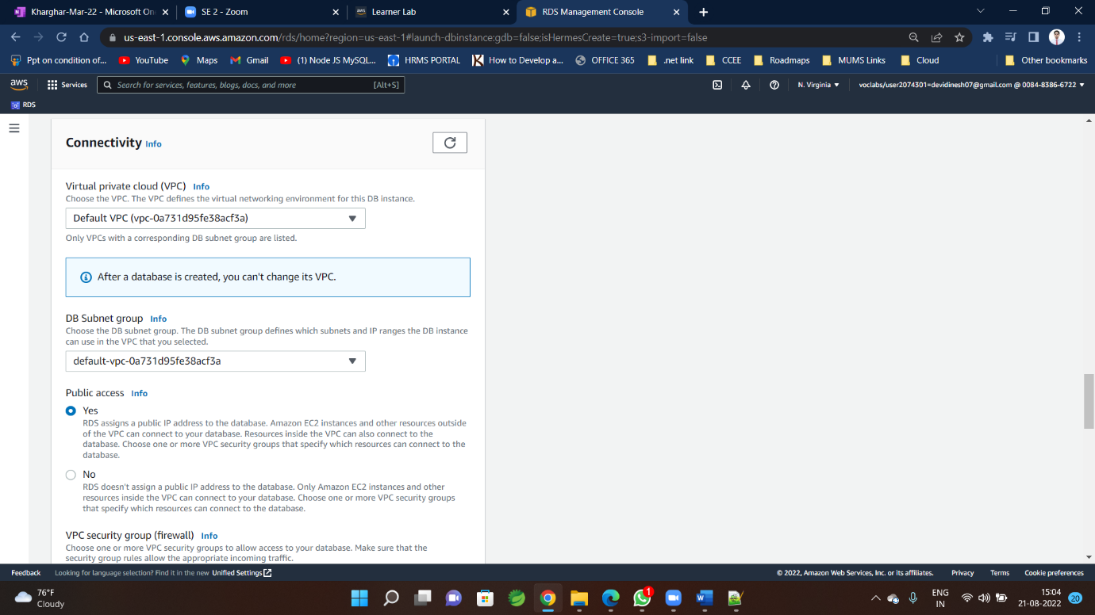

**Step-10**

**Create new security group and give name**

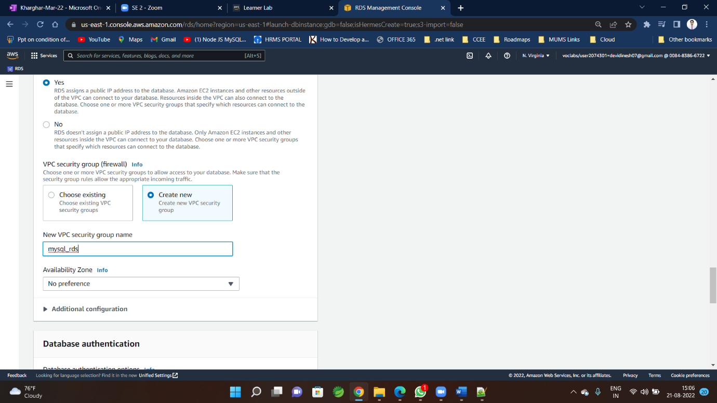

**Step-11**

**Password authentication (Leave it as it is)**

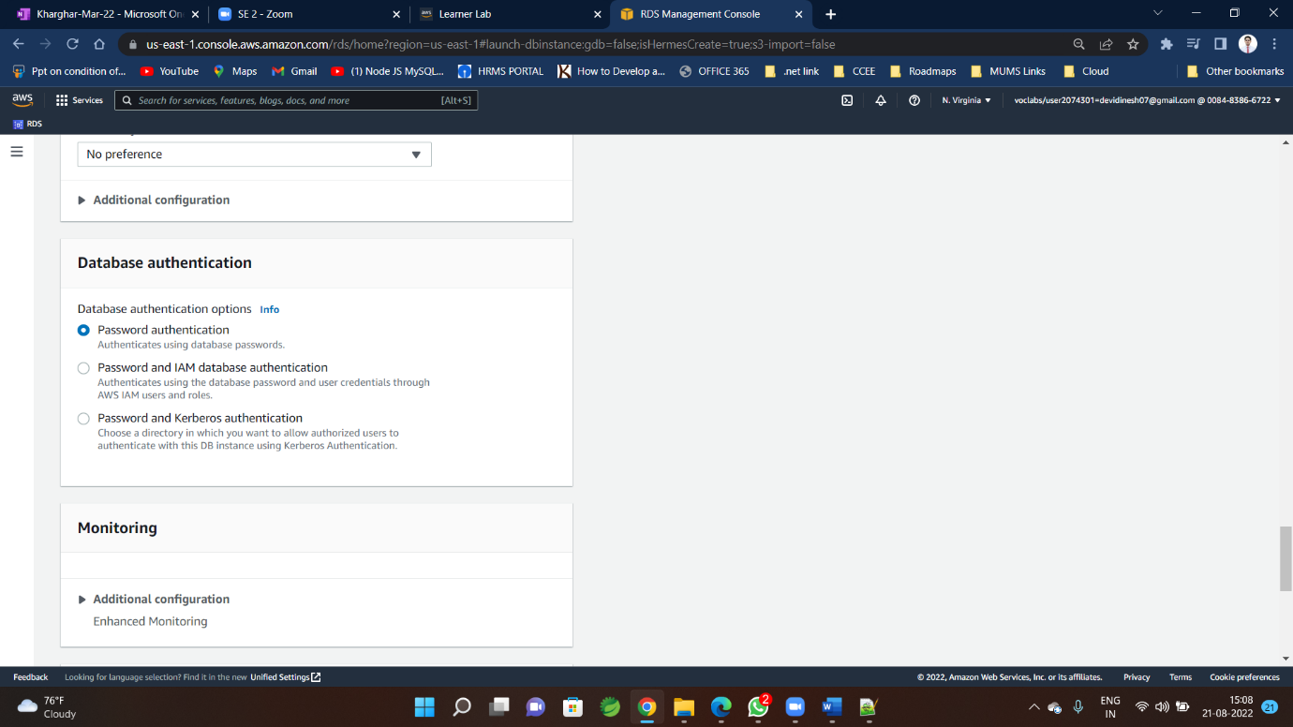

**Step-12**

**Click on create database**

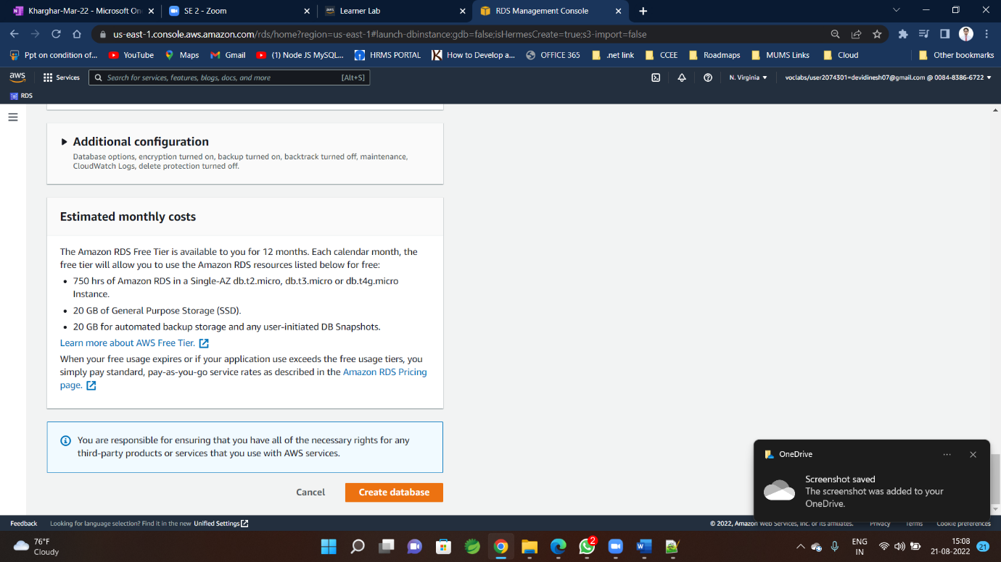

**Step-13**

**It will take some time to create Database**

**Copy and keep your database password from here**

**And keep at safe place**

